User Story:

The user will search for a product on the web site.

The user will click on the product’s image, will read the description, will choose the quantity, click on the price and the product will be added to the basket.

The user can change the quantity of products in the basket.

The user also has the possibility to delete every product with a delete button.

The total amount is written on the checkout button.

The user clicks on the checkout button and transfers to the checkout page.

The user writes the delivery data and chooses the payment method.

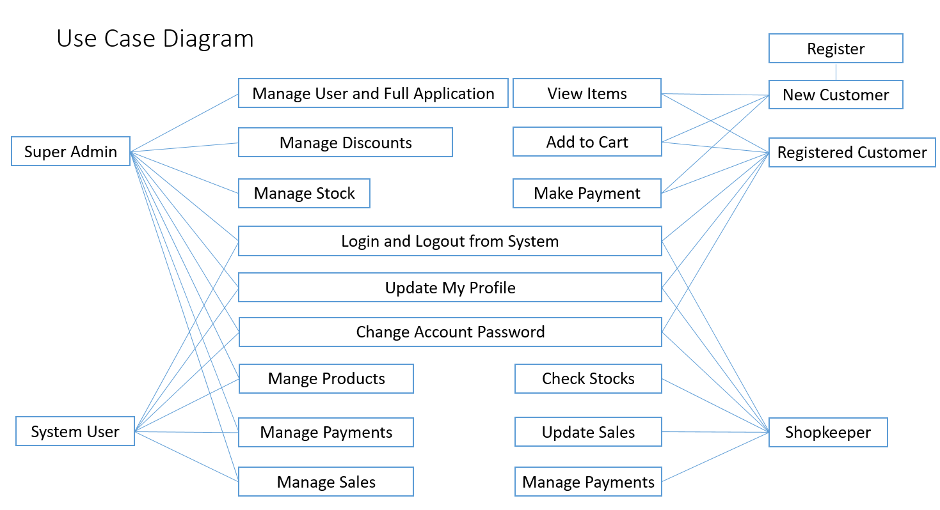

Classes Diagram:

